**Introduction to the Affordability (originally Bertaud) Model**

**Jerry Erbach – June 2012**

“Meeting the basic human need for shelter is a key component of community resilience, both in the immediate response to a disaster event, as well as long-term recovery and an eventual return to normal economic functionality. The availability of housing that is affordable is a crucial factor, underlying many other community functions, as people must have a stable place to live to be active participants in the local economy as workers or consumers, to send their children to school and to engage in civic activity.” (from “Roadmap to Enhanced Community Resilience – Availability of Housing that is Affordable” – Community and Regional Resilience Institute and City of Gulfpoint; February 2009)

The availability of affordable housing is a key priority area in building resilient communities. In Haiti, as well as in many developing countries around the world, the lack of affordable housing is having a major negative impact on the resilience of local communities. This is especially true after the recent earthquake and the recurring hurricanes that affect the country. Strategies aimed at overcoming historical impediments to increasing the availability of sound, affordable housing are much needed. The exploration and identification of affordable materials and techniques to build and retrofit houses in a legal manner to withstand earthquakes and hurricanes are required. Existing regulations and high construction costs do not fit the abilities of the population to build their houses and consequently restrain the growth of affordable housing solutions.

The unavailability of affordable housing for a range of income levels is an ongoing hindrance to the long-term recovery from the recent earthquake. The urgency, complexity and stress of recovery have led many donors and organizations to pursue activities in highly targeted ways that do not consider the affordability of their units since no cost recovery is required from the beneficiaries. Different points of view on any IDP payment for their housing units and the lack of integrated efforts to address the housing situation have made GOH efforts to establish a resilient housing supply system for today and future all the more difficult. Nevertheless, the broad range of current housing efforts in Haiti should now begin to share a common objective to develop a sustainable and sufficient supply or acceptable, affordable housing.

Housing involves multiple sectors of the community. It has both up and down stream implications and impacts for both the economic and social well being of the community. It has a substantial economic multiplier along with important social benefits. It also speeds up a community’s response and recovery by providing a stable place for home and in-house work. In addition, it increases community awareness and preparedness, enables a practical and doable response at the household level, can build on existing community effort and adds value to the community.

The introduction of appropriate, low cost building technology into a community should be part of a sustainable process that is internal to the community, supports the growth of local architectural solutions and contributes to the development of indigenous capabilities as decided by the community. Such resilient technologies need to be economically appropriate, financially viable, environmentally sound, and within the management capacities of the local population. The affordability of these solutions, when compared to traditional approaches that are not affordable, will be key to their adoption by communities.

Across the world, the barriers to alternative building systems are beginning to decrease due to issues of affordability. Many of the more prescriptive and restrictive building regulations and codes are being reconsidered and made more responsive to public demand. More conscious building officials are beginning to see the potential of local / traditional materials to help the environment, health and welfare of their fellow-citizens. The use of the Affordability Model is one way to compare the affordability of different housing solutions and to identify those appropriate in building resilient communities.

As shown in the following figure, it has evolved over the years from a simple graphic approach into a more complete computer based approach using what-if spreadsheet technology. The Affordability Model has been used and tested for low income housing in a number of countries and has been complemented by additional spreadsheets for site and housing development. These additional spreadsheets enable a large number of project parameters and costs to be evaluated in what-if fashion and do obtain much more precise estimates for %circulation, site development cost per m2 of site, housing unit size in m2 and construction cost per m2 of unit. All of these parameters can be determined through a simple simulation of what one conceives the project to be. It enables alternative approaches and reduces standards to be evaluated against existing codes and requirements.

The Affordability Model has been developed using relatively straightforward and simple formulas that have been incorporated into a one-page computer spreadsheet. A copy of this page and a flow diagram of the inputs and outputs of the model are shown in the following figures.

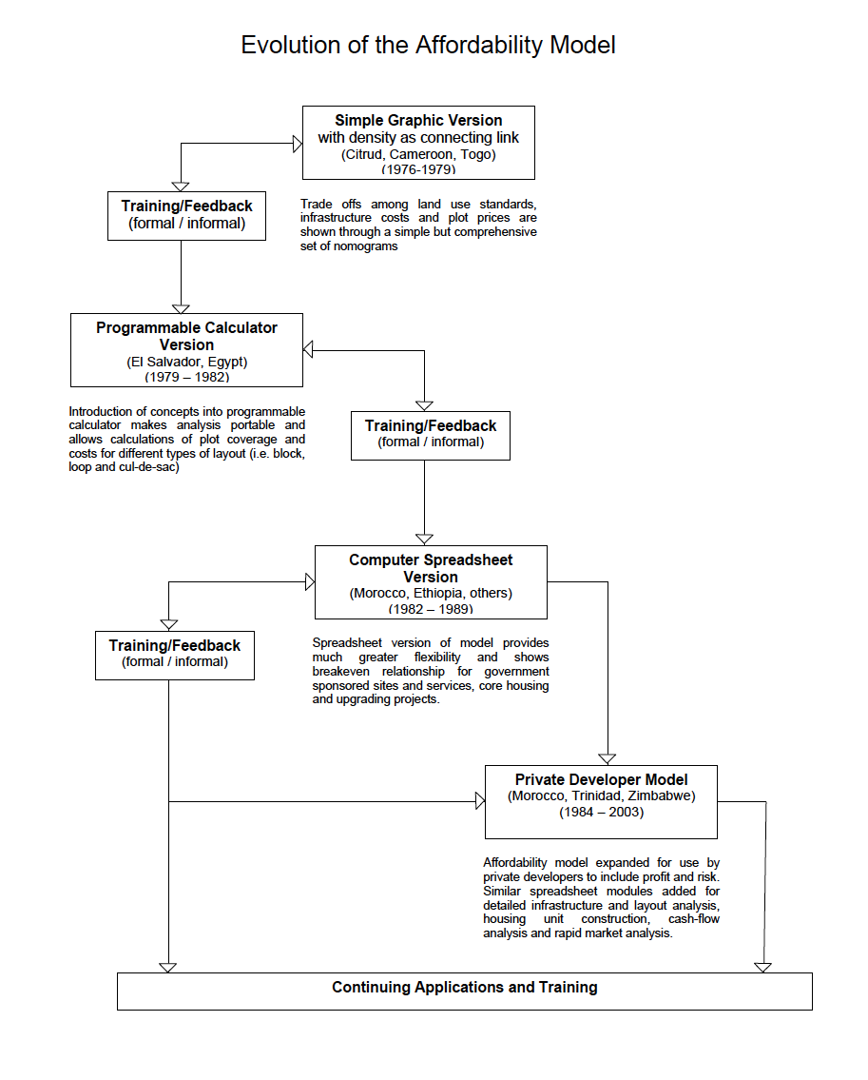

Example of the Affordability Model Spreadsheet

(Items calculated by the model are in bold)



Flow Diagram of Inputs and Outputs to the Model

